Robofan
Group 8/13
Ryan Rossbach - CS
William Terry - CpE
Floyd Thormodson - EE
Ivan Sarmiento - EE

No sponsors

Project Description
Workshops can get extremely hot, especially if airflow is sub-par. Even worse, you could be working out of a garage in Florida! Large fans might not always fit in a workspace, and if you are moving around you will get limited effect from a stationary fan or oscillating fan. We are going to design a small ceiling mounted fan that will track a person in a 360 degree area. The fan will be able to pan and tilt so as to point anywhere in the room. This allows for a smaller fan to have a much more precise and noticeable effect.
The fan will track the operator via a Pixy camera mounted on the fan and a colored necklace or pin on the user. We will design a printed circuit board (PCB) that can take input from the Pixy camera and tell the motors where they need to point. The board will also have a bluetooth module so that it can communicate with a companion app. The easy to use app will be programmed in android and be able to change the fan mode(auto/manual/pattern/etc) and control the fan in manual mode. Finding out if distance calculations via the camera is possible would be important as well. If we can gauge distance then it would be possible to have the fan blow at different powers to keep a certain perceived level of breeze on the operator. We could also integrate a thermometer or use the phone's thermometer to adjust fan power.
Useful constraints for this project would include minimizing its weight. As we wish the fan to be installable a lower weight allows ease of placement. We would also like to minimize the cost as much as possible. A lower cost per unit allows less stress on a small team building the fan that could be strapped for cash. Further, the camera used should be capable of outputting a high resolution image to be used in the phone application.
In short, the technical goals of our project are to design an installable fan that will track a user around an area.
Alternate methods that could be used to achieve a similar goal are as follows. A Pixy camera could be replaced by any camera that can see infrared, such as a security camera, due to being more readily available. An app designed for Android use is not strictly necessary for operation of the fan, but an app could be designed for use in an Apple environment. The core fan being used to cool an area could be replaced with something like a hair dryer for colder climates that might wish an area to be targeted for warming rather than cooling.
Broader Impacts
This project will ideally be used by anyone with a workshop space that cannot afford to have it properly cooled. It would act as a quality of life improvement for workshop users that would allow them to function in a "hot" environment for sustained periods of time. Additionally, it would be an ideal fan for disabled people that may have difficulty moving a fan to whatever position they may move to in a room, while staying useful.

Known Standards
-IEC(international Electrotechnical Commision)
TC 59 - for home appliances
-VESA
-IEEE

Requirement Specifications

Name | Description | Target
Pan Speed | The device will turn fast enough to keep up with an average walking speed of 3.1 mph | >4 mph
Detection Range | The detection range will be suitable for an indoor workshop or garage | 15 feet
Communication Range | The user app will be able to function at a greater range than the device’s detection range. | >30 feet
Power | The device will not use much more power than what an ordinary oscillating fan uses. Wattage will vary based on fan speed and how actively the fan/user moves | <160 Watts
Length | The length of the device (from mount to top of fan) will be suitable to work within an average American home with a ceiling height of 8 to 9 feet. | <18 inches
Pan Range | The pan motor’s degree of rotation will not be limited to a specific threshold. The device will be able to rotate in any direction continuously. | >360°
Tilt Range | The tilt of the elbow joint will allow the fan to point directly below the mount. The fan will be able to tilt close to 90° from this position in either direction. | <180°
Weight | Since the device will be mounted to the ceiling, the lighter it is the better. | <10 pounds

- Device does not need to be highly accurate.
  - The device will point at the target within half the width of the fan to ensure it is hitting the user without unnecessary movement.
- Automated movement can be disabled and the device can be controlled by an onboard panel.
  - Fan speed and orientation can be adjusted.
- The device can be controlled using an app connected via Bluetooth.
  - This allows the device to be remotely or manually controlled.
- To conserve energy the device will systematically shut off features.
  - First, the fan will be powered off if no user is detected within 10 minutes. The device will completely power off if no user is detected within an hour.
- The device will meet relevant safety standards.
- Device will be able to detect more than one specific user.

Prototype Sketch
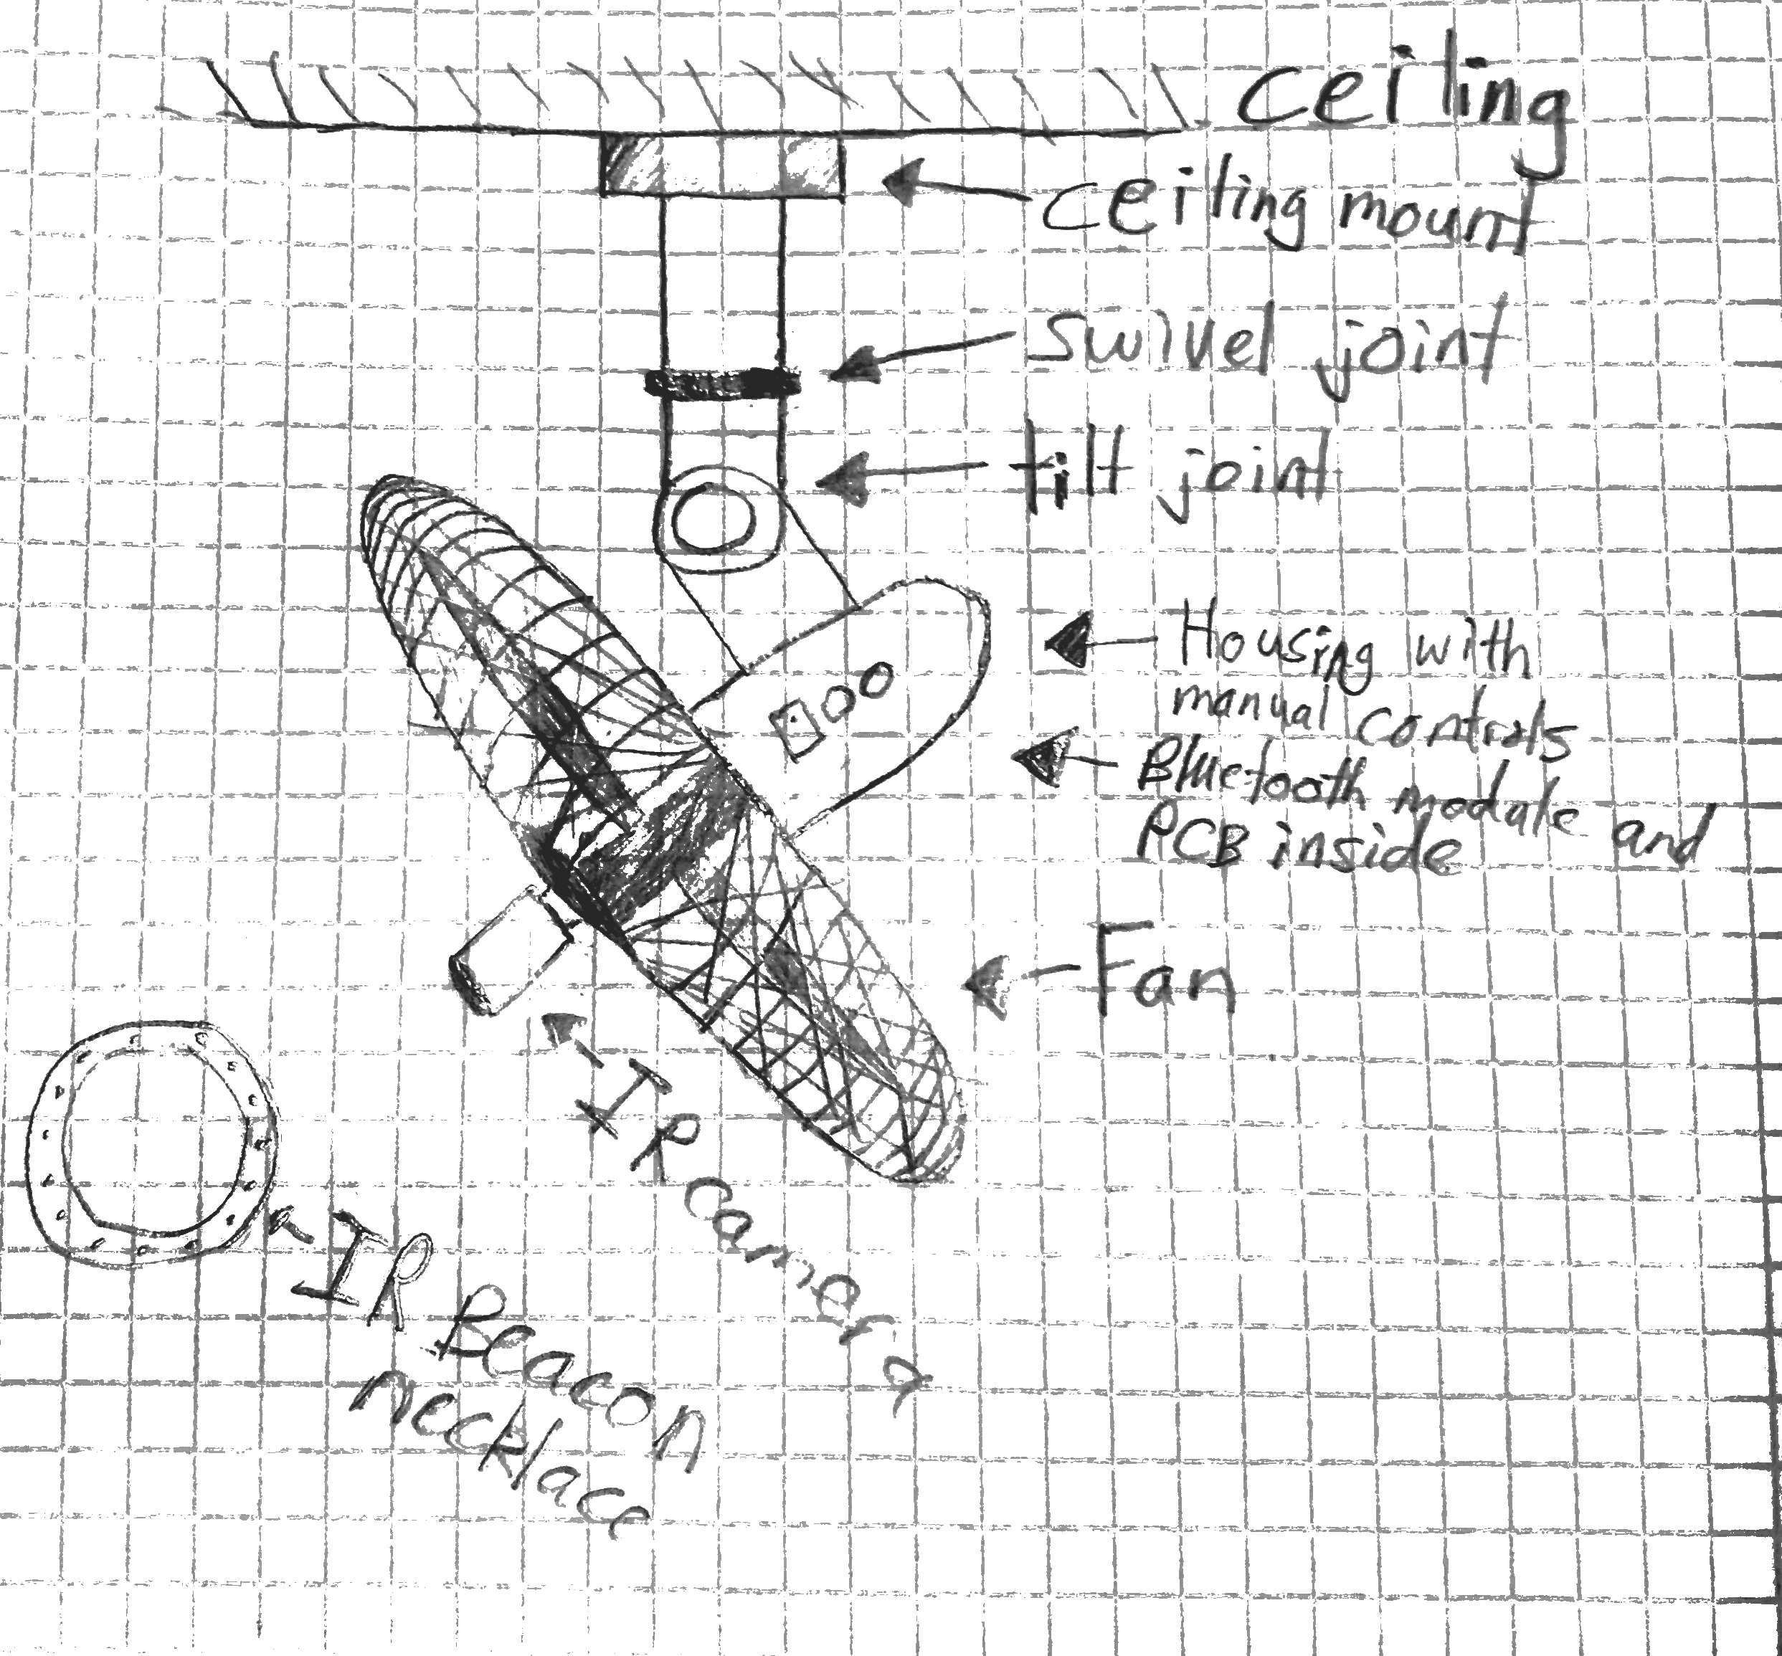
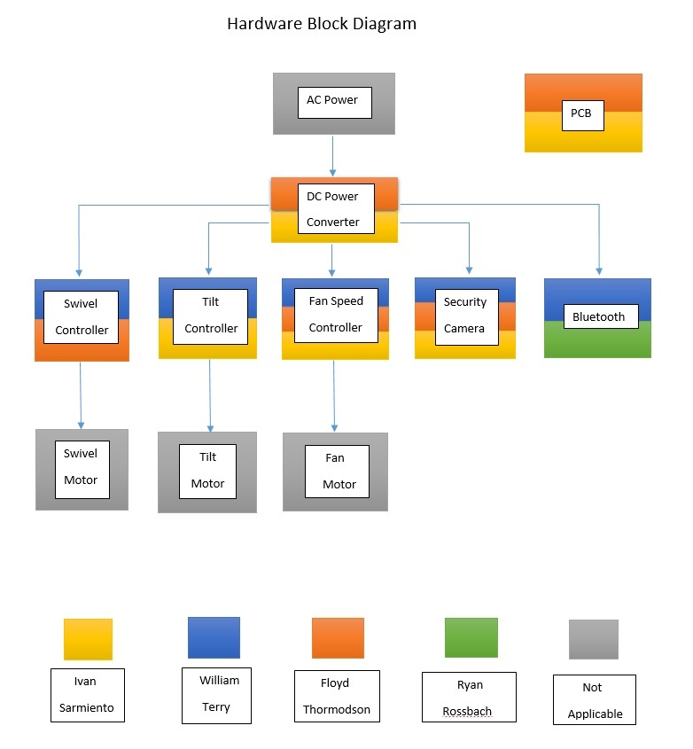
- All blocks are in the process of being researched.
- All blocks are currently in the design process.
- No blocks have been acquired or purchased.
- No blocks are being prototyped as of yet.
- No blocks have been completed

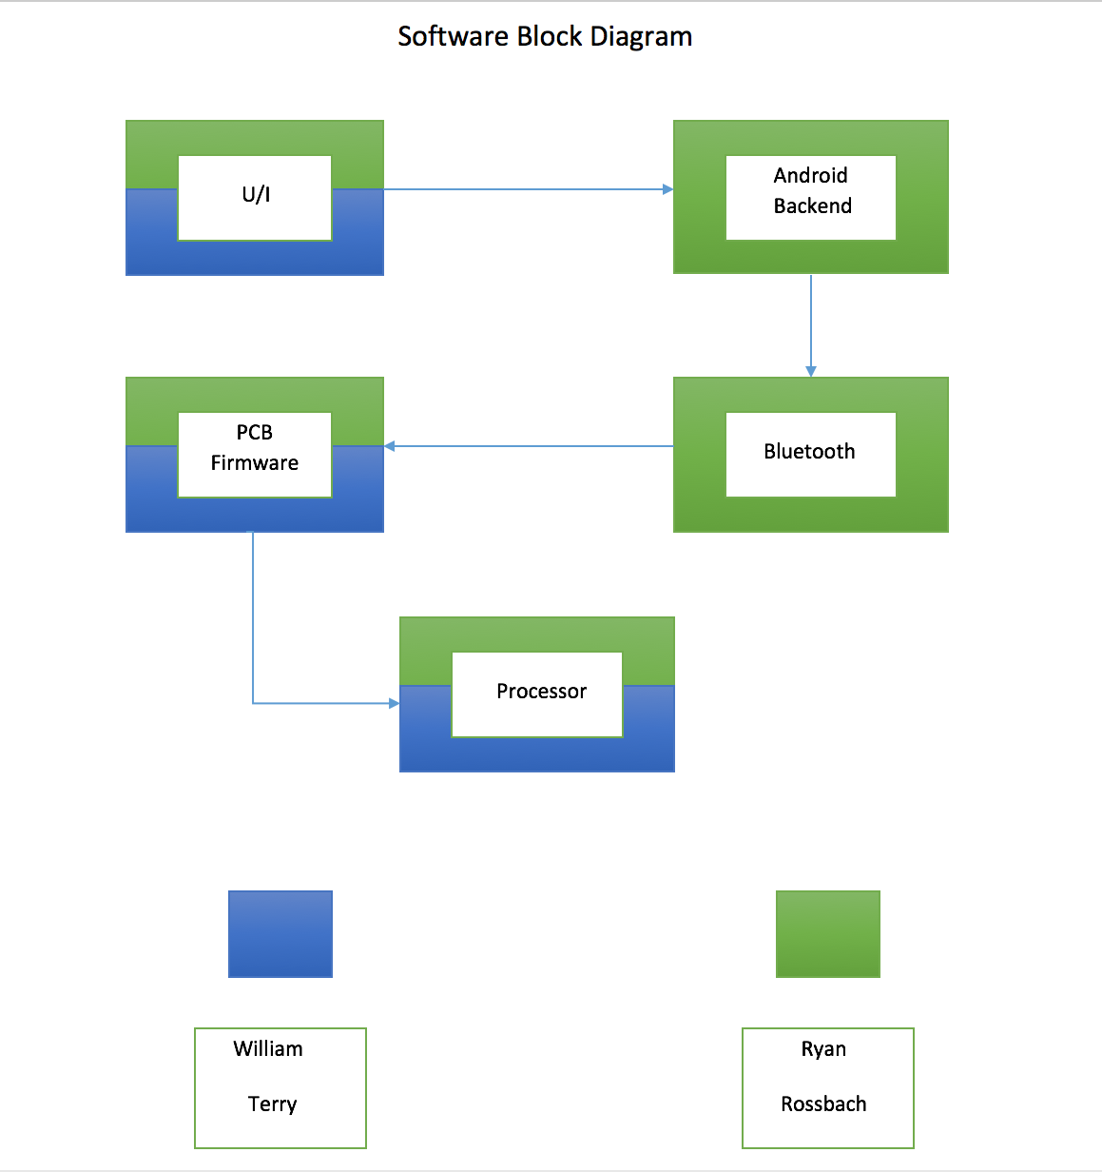

- All blocks are in the process of being researched.
- All blocks are currently in the design process.
- No blocks have been acquired or purchased.
- No blocks are being prototyped as of yet.
- No blocks have been completed

House of Quality

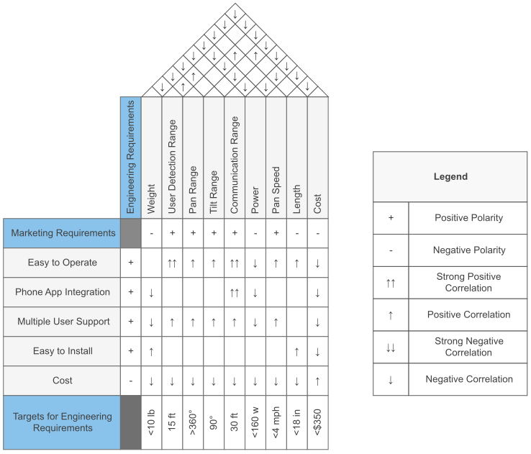

Estimated Budget and financing
Item | Quantity needed | Price($) | Total Cost($)
Oscillating Fan | 1 | 20-30 | 20-30
AC-DC power converter | 1 | 10 | 10
Stepper motor | 1 | 20-30 | 20-30
Stepper motor controller | 1 | 5-20 | 5-20
Servo motor | 1 | 15 | 15
Servo controller | 1 | 5-10 | 5-10
Fan motor controller | 1 | 5-15 | 5-15
Pixy Camera | 1 | 70 | 70
Bluetooth Module | 1 | 8 | 8
PCB | 2 | 30-40 | 60-80
ARM CPU | 1 | 2 | 2
Power Switch | 1+ | already have | 0
Slip ring | 1 | 10 | 10
Tilt joint | 1 | 10 | 10
Wires and other consumables |  | 20 | 20
Total |  |  | 230-330

We are planning to look for a sponsor, but if we cannot find one we are prepared to finance this project ourselves.

Project Milestones
Number | Task | Start | End | Status | Responsible
Senior Design 1
1 | Divide and Conquer | 1/21 | 1/28 | complete | All Members
2 | Initial Design Document | 1/24 | 1/28 | Not Complete | All Members
3 | Individual Research | 1/30 | 2/10 | In Progress | All Members
4 | Dr. Richie meeting | 2/13 | 2/14 | Complete | All Members
5 | 10 page submissions | 2/10 | 3/5 | Complete | All Members
6 | Group check in w/TA, 10 pages each | 3/5 | 3/5 | Complete | All Members
7 | AutoCAD Model | 3/10 | 3/16 | In Progress | All Members
8 | Critical Design Review Presentation | 3/6 | 3/25 | Not Complete | All Members
9 | Meet w/ Heinrich | 3/26 | 3/26 | Not Complete | All Members
10 | Group check in w/TA, 25 pages each | 3/27 | 4/9 | Not Complete | All Members
11 | Final Design Document | 4/10 | 4/25 | Not Complete | All Members
12 | Begin ordering parts | 4/23 | 4/25 | Not Complete | Floyd, Ivan, Will
13 | PCB design finalized | 3/10 | 4/27 | Not Complete | Floyd, Ivan
14 | Final Paper submitted | 2/10 | 4/27 | Not Complete | All Members
Senior Design 2
15 | In class CDR | 7/5 | 7/5(?) | Not Complete | All Members
16 | Phone Controller App | 3/10 | 7/15 | Not Complete | Ryan, Will
17 | Completed Prototype | 6/1 | 7/18 | Not Complete | All Members
18 | Heinrich Demo | 7/19 | 7/20 (?) | Not Complete | All Members
19 | Senior Design Conference Paper | 7/31 | 8/1(?) | Not Complete | All Members
20 | CECS Showcase | 7/31 | 8/1(?) | Not Complete | All Members

